Q1)

a)

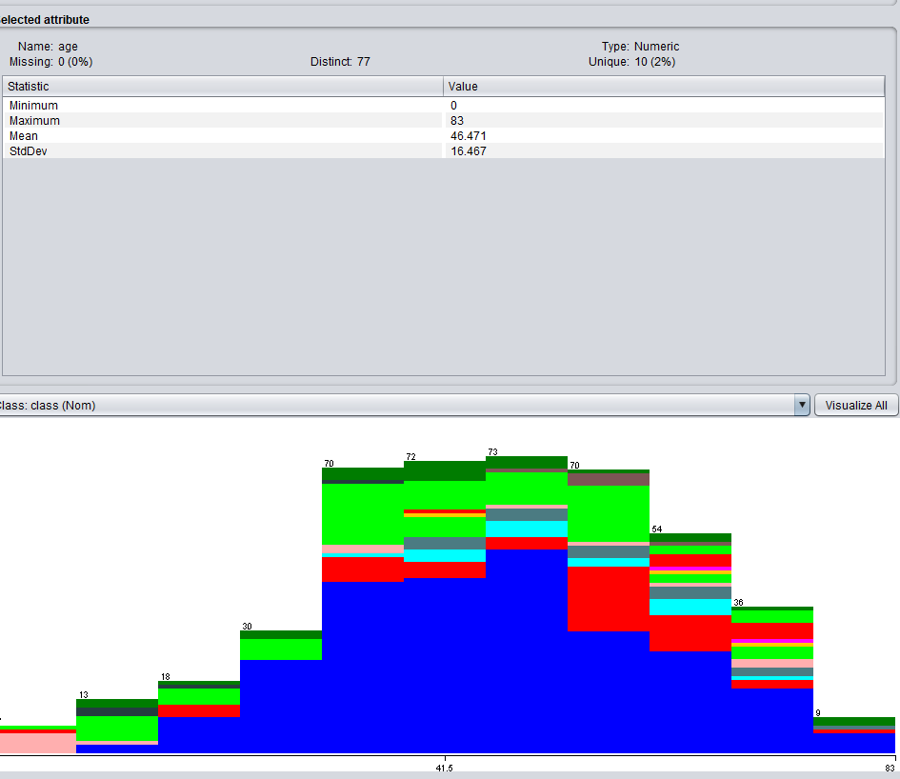

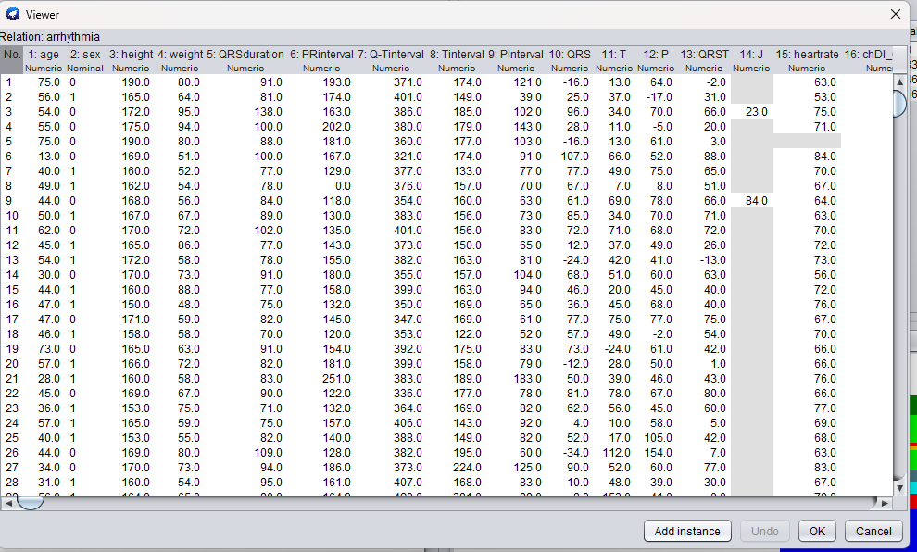

1-Some Attributes have missing values like 14

2- some attributes have no value i.e 0

3- the overall dataset is not normal

4- removing columns with great number of null values

5- filling missing values with mean

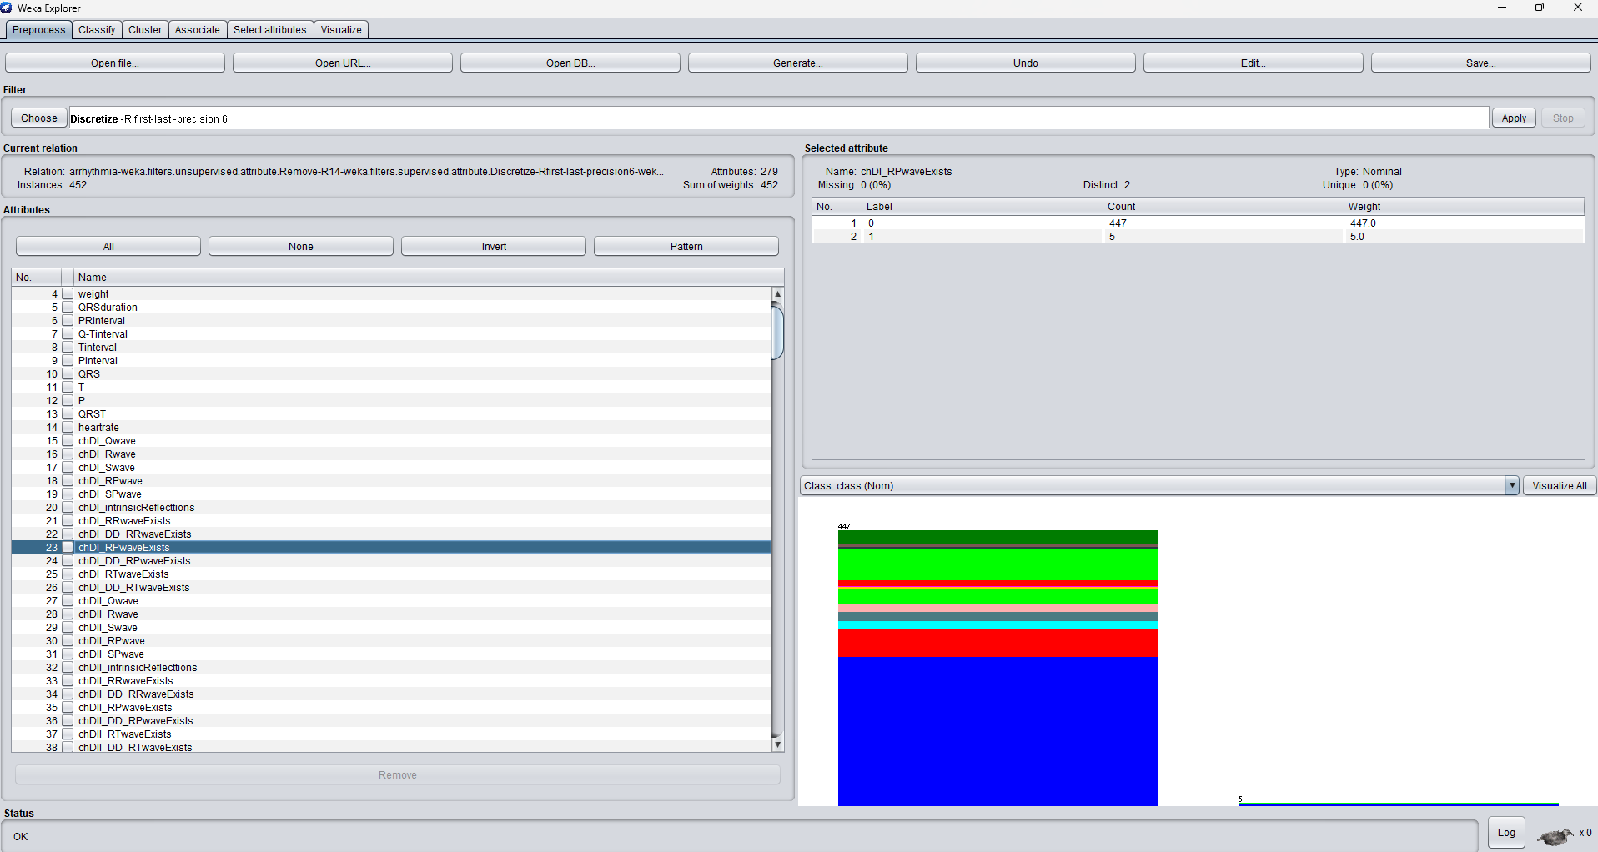

b) I made he data dicrete and removed some columns that were having missing values and could not be replaced by mean

Q2)

Used Decision Tree

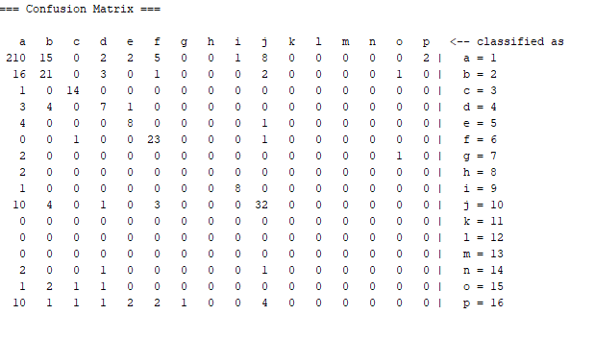

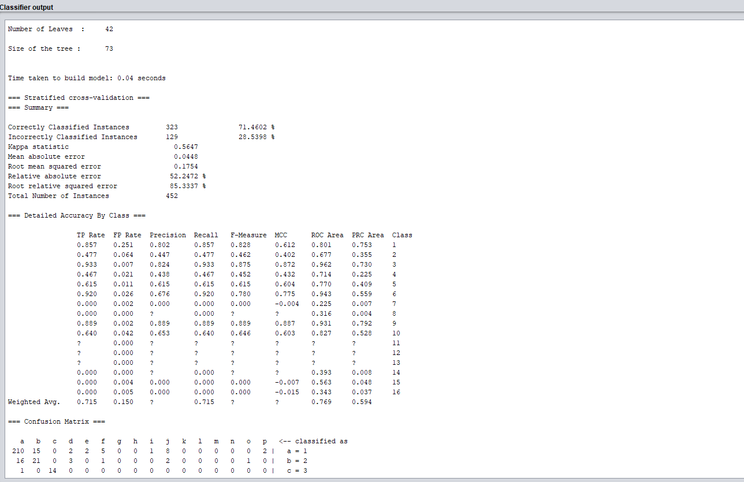

Naïve Bayes Classifeier

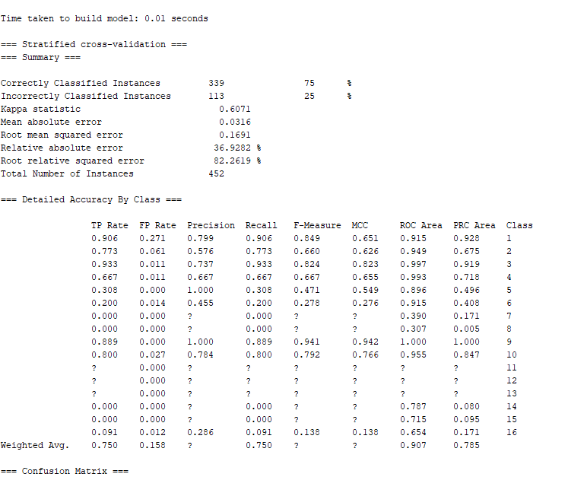

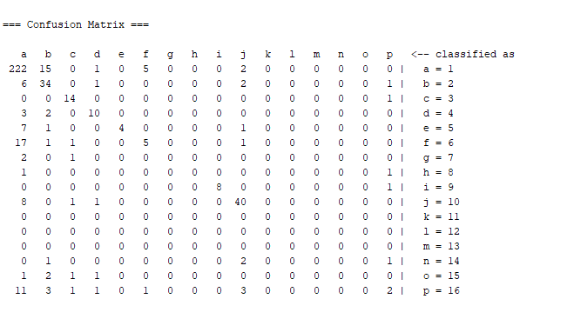

**SVM**

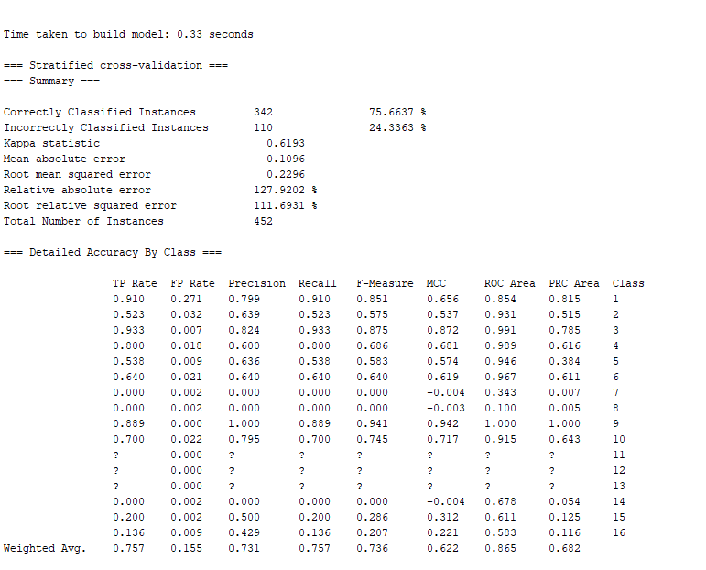

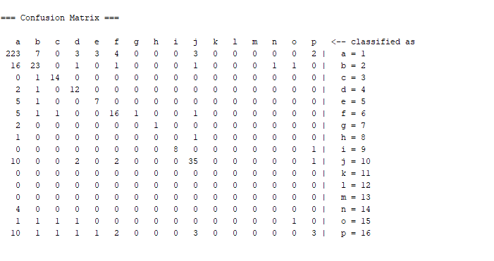

**Decision tree 71**

**Naïve bayes 75**

**Svm 75.6**

**Svm is best classifeier**